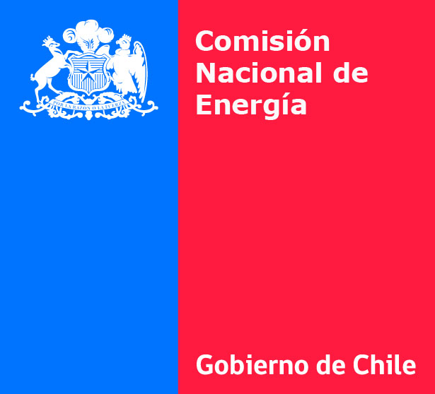

THIRD TARIFF-SETTING AND EXPANSION
PROCESS FOR TRUNK TRANSMISSION SYSTEMS

PRE-QUALIFICATION OF CONSULTING COMPANIES
FOR TRUNK TRANSMISSION STUDY

The Chilean National Energy Commission, in conformity whit article 88 of the General Electric Services Law and Exempt Resolution CNE N° 544 of september 3th 2013, published on its web site, www.cne.cl , calls domestics and international consulting companies with experience in electric transmission system planning and appraisal studies to present their background information for the process of pre-qualification of consultants eligible to carry out the Trunk Transmission Study, as part of the tariff-setting and expansion process for trunk transmission 2015-2018.

The pre-qualification specifications will be available on the National Energy Commission’s website, www.cne.cl, no later than Monday September 16th 2013.

CHILEAN NATIONAL ENERGY COMMISSION

